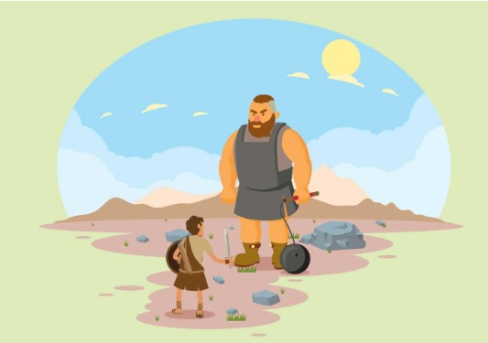
Week 2: Bible Story – David and Jonathan, a friend indeed
The Bible tells us that David was a person who was dear to God’s heart (Acts 13:22). He understood about the gift of friendship and tried both to make friends and be a friend all his life. Of course, he was also human and made mistakes, but he knew God wanted him to choose friendship, not hatred. Even when King Saul turned against him after the defeat of Goliath, he tried to stay friends with him. David refused to raise his hand against King Saul, who had chosen to hate David. Once he spared his life, when it would have been very easy to choose the way of violence instead (1 Samuel 24).
We see David’s capacity for friendship best in his relationship with Saul’s son, Jonathan, with whom he made a lifelong pact (a covenant) of commitment (1 Samuel 18:1-3). This was worked out both when Jonathan saved David’s life (1 Samuel 20) and much later when he cared for Jonathan’s crippled son, Mephibosheth, rather than take revenge on Saul’s descendants (2 Samuel 9). David was trying to work out the commandment to love his neighbour as himself (see 1 Samuel 20:17). When David heard of Saul and Jonathan’s deaths in battle, it broke his heart (1 Samuel 31). From David’s life, the theme of friendship in the face of hatred shows in two incidents in particular (Jonathan and David became friends and the killing of giant Goliath).
Bible Story Discussion
1. Explain how Jonathan and David became friends, following the killing of giant Goliath.
2. David ends up on the run from King Saul, Jonathan’s father. He relies on Jonathan for insider information about approaching danger (1 Samuel 20) at a cost. Jonathan almost gets himself killed.
3. The depth of the friendship between David and Jonathan is shown particularly in David’s reaction to the death of Saul in battle. It would have been extraordinary at the time to show such public remorse at the death of an enemy. Such sadness was the mark of being a true friend and an indication that hatred had been turned to love.
Discussion point answers
1. They stayed friends all their life, despite enormous pressures and dangers.
2. Although there was every reason for David to hate the king, when the chance came to kill him, David refused to harm ‘The Lord’s anointed’.
3. Read what Jesus says about what a Christian’s attitude should be to their enemies (Matthew 5:43-45). Long before Jesus, David showed that it is possible to choose the way of this kind of friendship.
4. The depth of David and Jonathan’s friendship is proved much later by the way David acted towards Mephibosheth, Jonathan’s son (2 Samuel 9). He did not need to show such kindness, but he did. True friends are prepared to go out of their way for each other. What a surprise it must have been to David’s court to see him acting in this way towards Mephibosheth.
5. For a time of reflection, ask the class to write out the names of all their friends on separate pieces of paper and then arrange these randomly in a circle. Place a candle in the middle. Now ask everyone in the group to choose a name other than the one they have written and call it out, so that all the friends are named in a time of thanksgiving for the gift of friendship.

